**Solution to implement development**

**Task 1:**

**copy table UserFunction, UserCheckBy, Offices, Employees including data from LOD_FreshVersion to LOD**

Test scipt deployment ‘

1. Create database “test”
2. Run scipt 1_Task1_XCASRVBI004_MoveTable.sql on database “test”

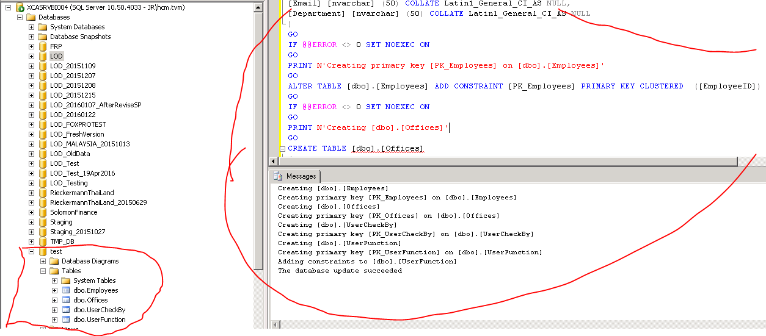

1. Run scipt 2_task1_XCASRVBI004_Movedata on database test

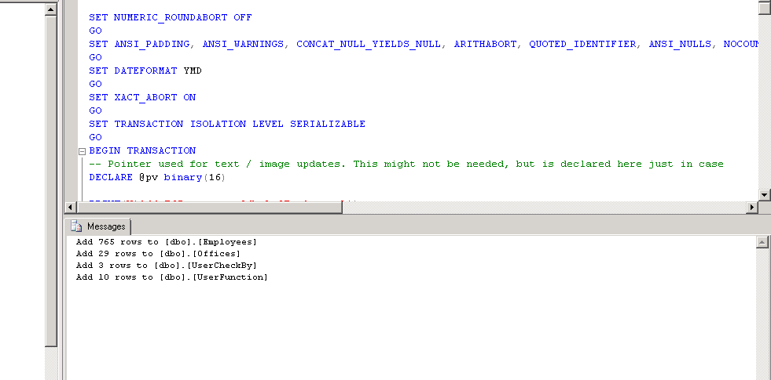

1. Compare data between test database and LODFreshVersion

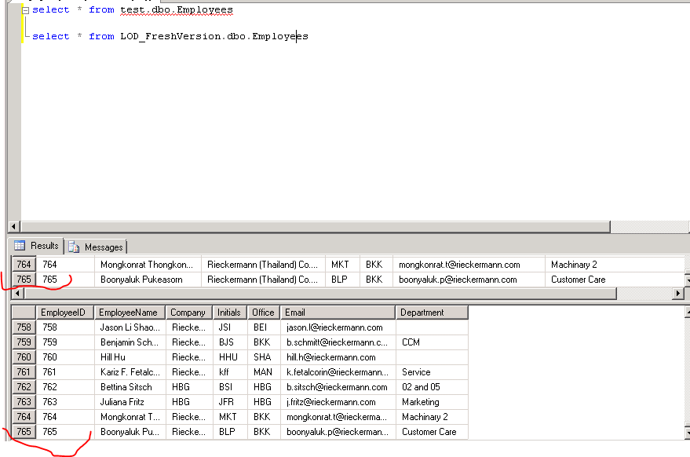

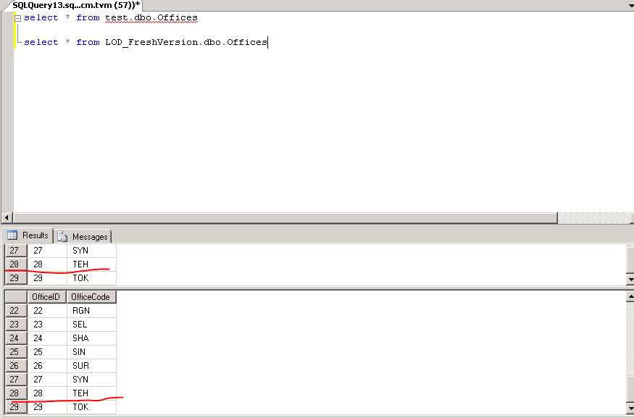

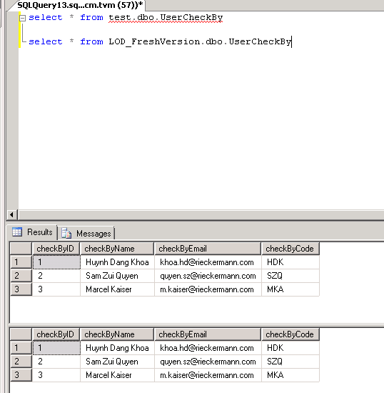

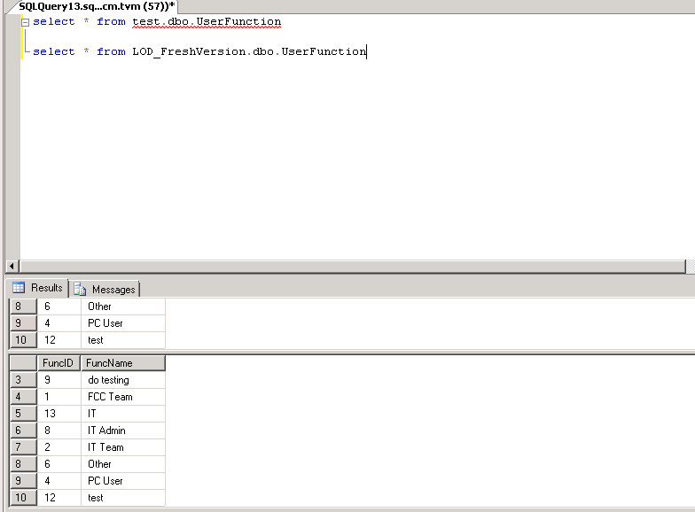

**Instruction deployment**

1. Run script **1_Task1_XCASRVBI004_MoveTable.sql** on database LOD
2. Run script **2_task1_XCASRVBI004_Movedata.sql** on database LOD

**Rollback instruction**

1. Run script **RB_1_Task1_XCASRVBI004_MoveTable.sql**

**Task 2 : Update data OfficeCode from UserName in Users table**

trong table: Users -> column UserName format no dang xxx.yyy

lay phan xxx roi make upper case roi update tuong ung vao column OfficeCode

[‎5/‎19/‎2016 10:37 AM] Huynh Dang Khoa:

record nao ma UserName co format ko phai la xxx.yyy thi ko lam dong tac update qua officeCode

vd hkg.bc thi update qua OfficeCode la HKG

truong hop Julie thi ko update

implement fix : create Store Procedure to update data OfficeCode

name of SP is [usp_UpdateOfficeCode]

Test SP

1. Create table Users in database [test] and copy data table Users from LOD_FreshVersion to table Users in database [test]
2. Create SP [usp_UpdateOfficeCode] on database test

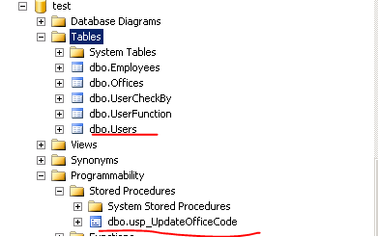

1. Compare data in table Users of Test database and LOD_FreshVersion

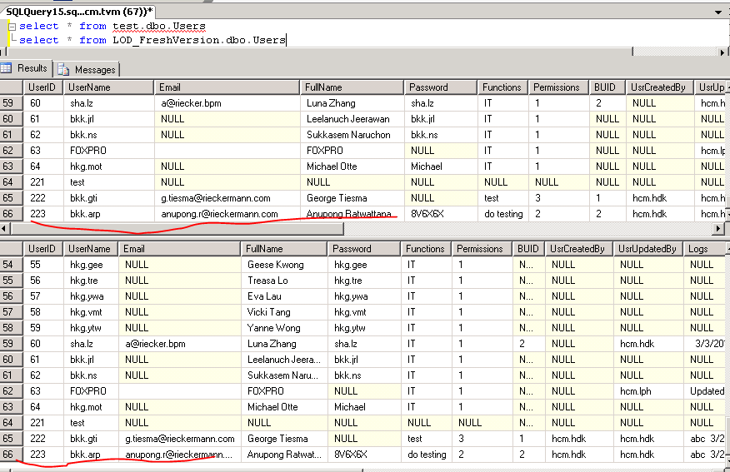

1. Run SP [usp_UpdateOfficeCode]

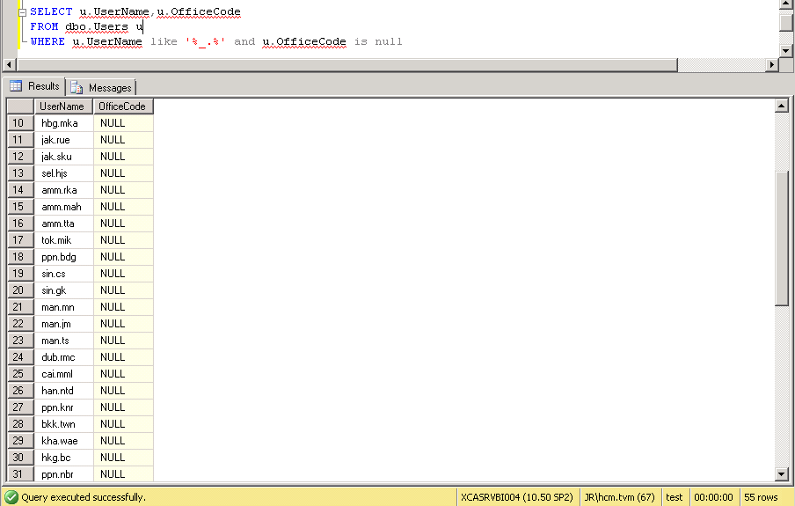

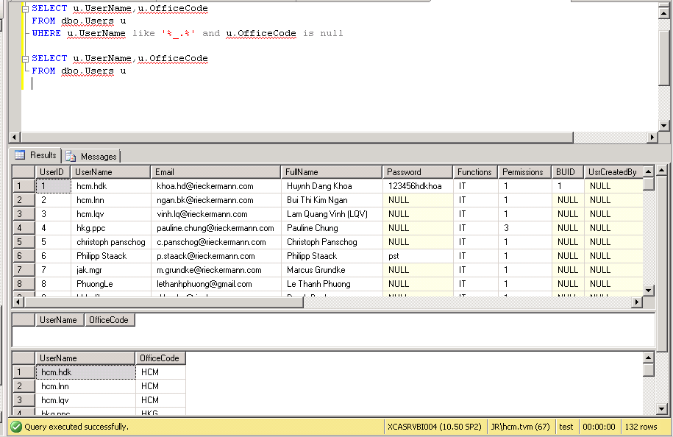

Instruction deployment

Run script **1_Task2_XCASRVBI004_UpdateOfficeCode.sql** on database LOD

Rollback instruction

Run script **RB_1_Task2_XCASRVBI004**_**UpdateOfficeCode.sql** on database LOD